Cooking with Lead and Tin: How to Solder Electronic Components to Your Printed Circuit Board

EEC 134 Technical Paper Final

Winter Quarter 2015

Francis Ambion ([Linkedin Link](https://www.linkedin.com/in/fambion))

Team Innovio

**1. What is Solder?**

Solder is the glue that holds the components to the board. Solder is a metal material with a low meting point. The metal composition consists of tin, lead, or a combination of the two. The solder is applied by heating the metal until it melts into a fluid and flows to cover and hold the components onto the board, usually on metal contact pads (note, this process will be covered later in this how to guide). If a PCB is coated with a soldermask material, it will protect the channels and interior parts of the board. The soldermask is built to be solder resistant, meaning that molten solder will not stick to the mask and would rather stick to more metal surfaces such as the component pads or exposed channels. There are two types of solder: solid solder, usually found in wire form and solder paste.

The labs for this class use both types of solder.

**2. Types of Solder and Flux**

**A. The Wire is your Desire! : Solid Wire Solder**

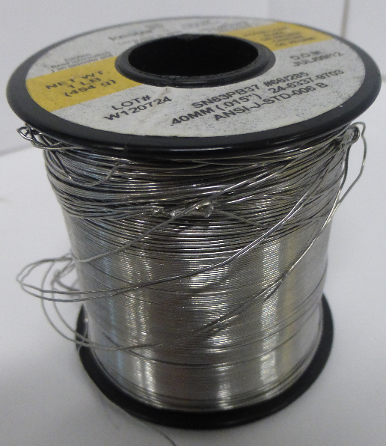

Figure 1: A spool of solder wire used primarily with through hole components

Wire solder is used mostly for through hole components. Wire solder is the most common solder and the easiest to use and apply.

*Pros*: This is the easiest and fastest way to solder by hand.

*Cons*: Smaller components become near impossible to solder because of the need for a very fine tip on the soldering iron and the component pad.

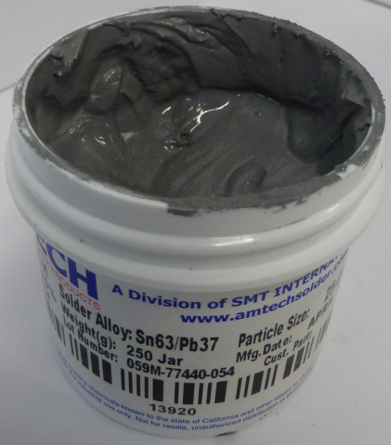**B. Now that’s what I call a Sticky Situation! : Solder Paste**

Figure 2: A container of solder paste with a mixture of 63%tin and 37%lead combined with flux

Paste is primarily used for adhering surface mount components.

The solder paste consists of really small particles of solid solder mixed together with flux (see the next section)

*Pros*: Can be used for smaller components. This process is used to fabricate large quantities of PCBs because it can be applied in simple multi step processes.

*Cons*: Can take longer to do when applying by hand. Fixing mistakes is a lot harder and could damage the PCB pads

**C. What the Flux! : Flux**

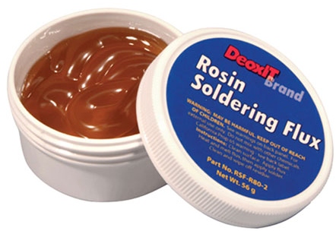Flux reduces the oxides that form when hot metals come in contact with the air.

The flux helps the metal solder to melt and flow more fluidly when hot. Most flux wire will have a rosin flux core, so it is not always necessary to apply the flux that is supplied in the labs. Most solder paste will be coated with come premixed with flux as well. In most cases flux comes in handy with solid wire solder, and desoldering PCBs

Figure 3: Flux in a container

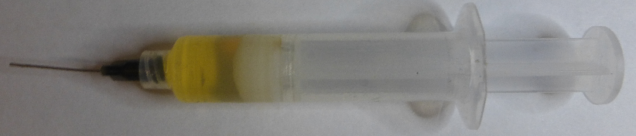

Figure 4: The flux from the lab in syringe form

Applying the flux is as simple as soldering. Simply apply the flux to the areas where solder will be applied and melted.

**3. The Red Pill or the Blue Pill: Through Hole or Surface Mount Components**

For the purpose of this tutorial, this guide will be divided into the two types of soldering techniques, through hole and surface mount.

**A. Through the Rabbit Hole: Through Hole Components and Soldering Techniques**

Through hole components are the most common types of electrical components.

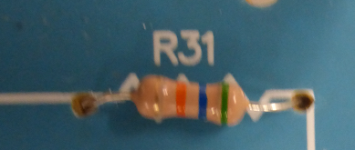

Figure 5: A standard resistor with its leads through the PCB holes

Each component has multiple leads that go through the holes of a PCB pad.

The component needs the solder to stay in the board. A soldering iron is needed to melt the solder onto the board.

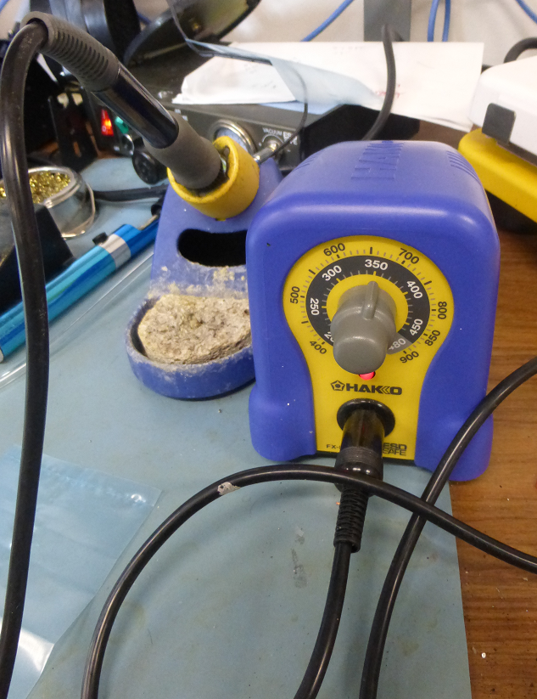

Figure 6: The soldering Iron used in the labs with adjustable temperature

The soldering iron is a metal pointed stick with interchangeable tips that heats up.

This soldering iron has adjustable temperatures that allows for different solders with different melting temperatures.

This soldering iron is set to 350C.

Most solder wire has a melting point of around 170-200C.

Put the component leads through the entire hole. The leads sticking out of the bottom of the board can be bent in opposite directions to help the component stay in place.

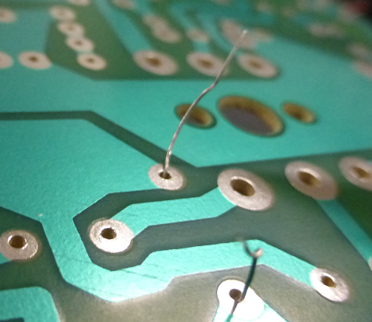

Figure 7: The leads sticking out of the bottom of the PCB ready to be set with solder

The component needs to be held down or secured in place. The use of vise grips and clamps to hold the board steady and in place is very helpful with hand soldering. You can also bend the leads of the component to help in this process.

Hold the solder wire in one hand and the soldering iron in the other.

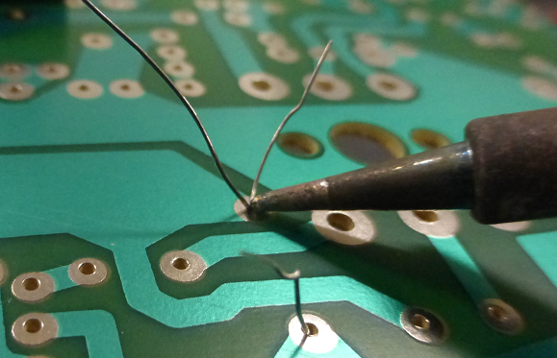

Figure 8: Press the solder wire to the hot tip of the soldering iron to melt it and to let it flow over the metal contact pad.

Touch the soldering iron tip to the place where the solder is needed.

Let the pad and component get preheated to allow for better flow of the solder later on.

The solder wire can be held straight and pushed to touch the area where solder is needed.

Once the solder wire touches the heated tip and pad it will melt and flow through the hole and over the pad holding the component in place.

The following shows the finished product of allowing the solder wire to melt on the pad.

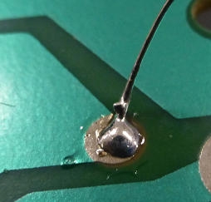

Figure 9: Image of a proper solder joint

**C. We’ve only just Scratched the Surface: Surface Mount Components**

Surface mount components rest on top of the metal pads. Solder paste is used for most surface mount applications to adhere the component to the pad.

There are multiple ways of applying the paste to the pads of the PCB.

i. Stencil

The stencil is the fastest way of applying solder to the pads accurately by hand without the use of computers

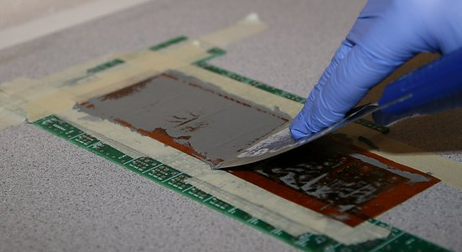An example of the stencil is a shown below

The stencil has a preformed mask with holes that are spaced to expose the areas of the PCB contact pads that need solder. The stencil is laid down on the pad and the solder paste is applied.

Figure 10: A stencil being used to apply solder paste to the contact pads. This can be done quickly and consistently.

ii. Don’t be a Chump use the Pump! Using the Foot Pump and the Syringe

The second way of applying solder paste is by applying it with a syringe and air pump

The syringe is prefilled with solder paste and can either push out the solder with a plunger or with air pressure activated through a foot pump. The syringe with the plunger is simply pushed with the thumb or finger. The only problem with this method comes when applying solder for very small components where pushing a slight bit might put too much solder (later on we will explain what too much solder looks like) on the pad or the hand holding the syringe could start to shake from the pressure applied to the syringe.

The best method for applying solder paste, besides the stencil, is to use the air/foot pump to control the flow of the solder paste. The solder extraction from the pump is controlled by a foot pedal.

The syringe attached to an air pressure line.

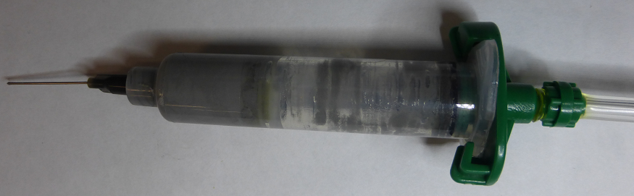

Figure 11: Image of the solder paste in the syringe connected to the solder pump

The interface of the air pump machine

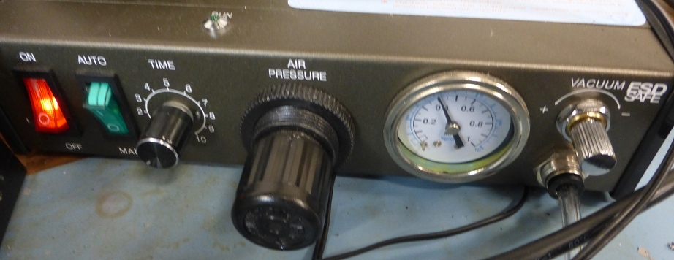

Figure 12: The interface of the air pump. The air pressure adjusts the volume of solder paste extruded each time the pedal is pressed.

The foot pedal controls the flow of the solder. Simply press the pedal and this makes the solder paste come out of the syringe in a controlled and consistent manner.

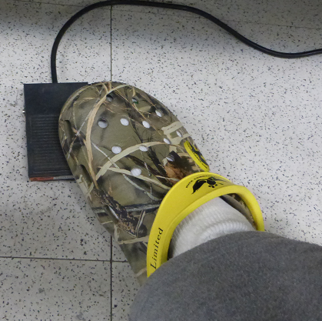

Figure 13: Step on the pedal to push out solder paste. The volume of solder paste is determined by how long the pedal is pressed.

The following image shows the solder pump at work

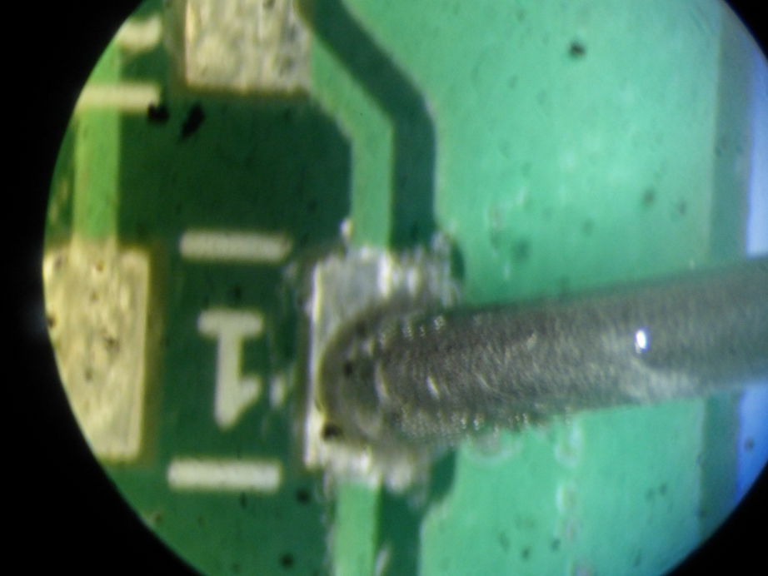

Figure 14: Extruding the solder paste from the syringe by the solder pump

iii. Goldilocks: Too Much, Not Enough, and Just Right: Determining the Correct Amount of Solder.

*Too much*: This pad is covered with more than enough solder. Too much solder may flow to another exposed pad, or worse, it may short the two pads together if close enough.

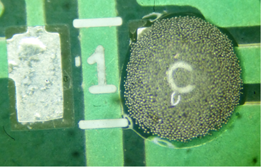

Figure 15: Image of having too much solder on the pad

*Not enough*: If the component is heated without enough solder it will not stick and fall off.

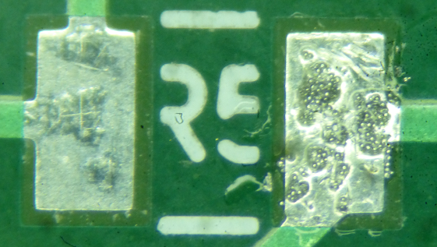

Figure 16: Image of not enough solder on the pad

*Just right*: The solder will melt and flow over the pad. The will also flow into the small grooved channels bordering the metal pad as well.

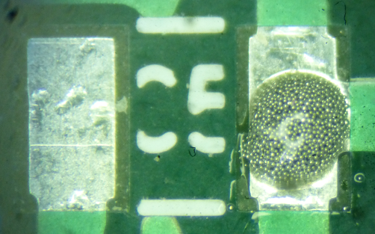

Figure 17: Image of having just the right amount of solder on the pad

**D. I Spy with My Little Eye: Using the Microscope**

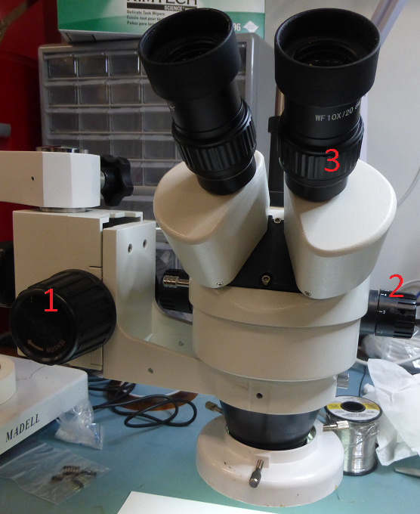

Figure 18: The standard microscope found in the lab

The microscope is the best way of soldering components that are very small and hard to see with the naked eye.

How to adjust the microscope in the lab:

1. Focus

2. Zoom

3. Visual Focus

**E. Setting Your Components Down on the Pad**

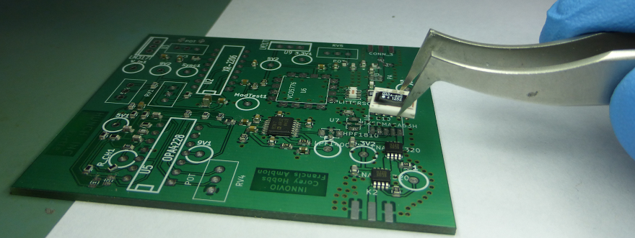

Figure 19: Tweezers are the best way of placing small surface mount component on the PCB accurately and precisely.

Setting your component on the pad is best done under a microscope, especially for small surface mount components. Simply place the components in the correct orientation on the paste and pad.

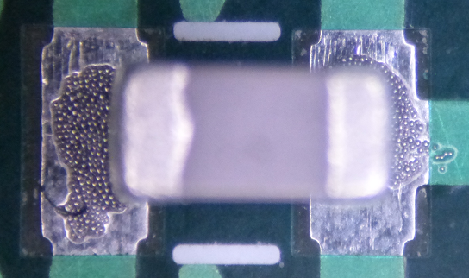

Figure 20: An example of a properly placed capacitor on the metal contact pads with solder.

Also note: All of the capacitor surface mount components found in the lab have no polarity to them. However, some surface mount inductors have polarity marks on them, so it does not hurt to double check which direction to place the component. It does not hurt to press down on the component [See Image] when it is on the pad with paste under it to keep the component flush with the surface of the PCB. This pushes out the excess solder underneath the component. The result of putting too much solder and not pressing down is shown later in this tutorial.

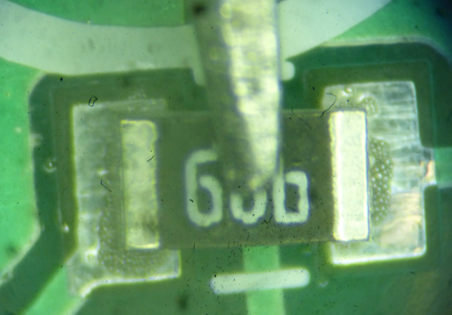

Figure 21: Pressing on the component lightly helps to set the component in place over the solder

**4. Now we’re Cookin’: Heating and Solidifying the Components to the Board**

There are multiple ways of heating and melting the solder. The main ways of heating the solder are to use the soldering iron, the oven, or the hot plate. For through hole, the soldering iron is the best method. The best methods for surface mount components are to use either the oven or the hot plate. This tutorial covers the use of the hot plate rather than the oven because it is faster and the PCB can be monitored while it is being heated.

**A. Sizzle Platter: Using the Hot Plate**

The hot plate will heat up the entire PCB from the bottom up, melting the solder paste.

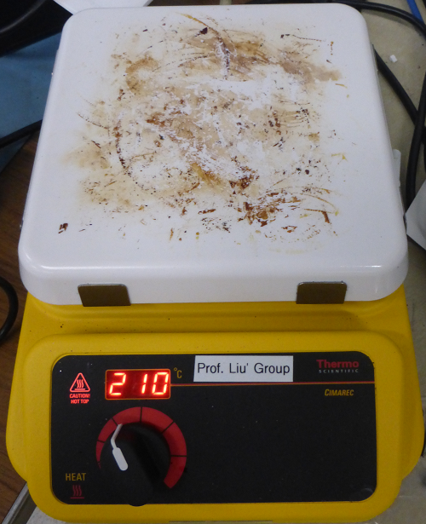

Figure 22: The hot plate with the set temperature used to melt the solder paste

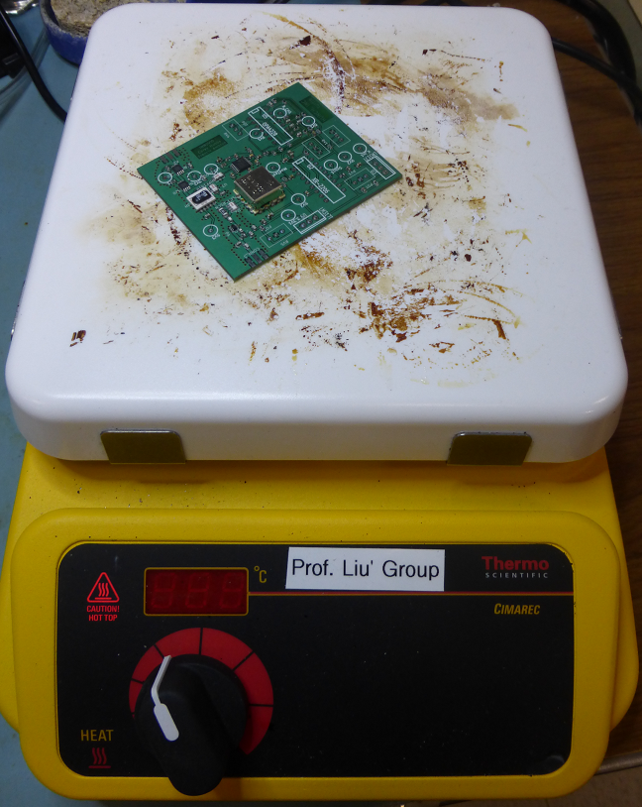

Figure 23: The PCB being heated up on the hot plate

When the plate is fully warm, the PCB should be gently placed in the plate or slid onto the plate with a piece of paper. The temperature for this hot plate was set to 210C. The solder melts in approximately 30 seconds.

A possible way to remove the PCB from the hot plate is to slide it onto a piece of paper then lift it off with the paper.

The last part is to inspect each of the solder joints to make sure that each of the components are properly seated on their respective pads.

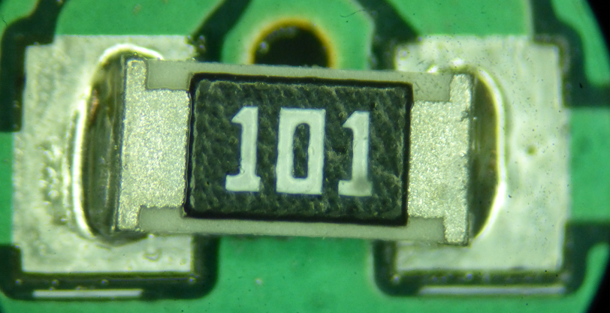

Figure 24: A well done solder with proper adhesion to the solder joints and component placement

The following image is the result of having too much solder and not pushing down on the component to set it properly on the pad. As the solder melts it flows over the pad. This component had too much solder underneath the resistor and moved as the solder flowed when it was heated.

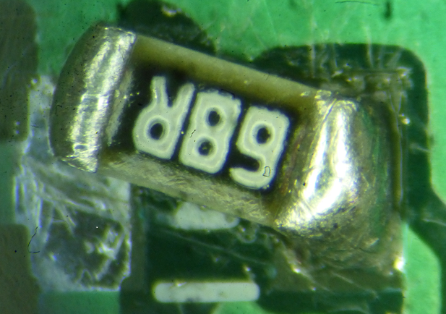

Figure 25: The result of too much solder. The molten solder moves the component as it flows over the pad.

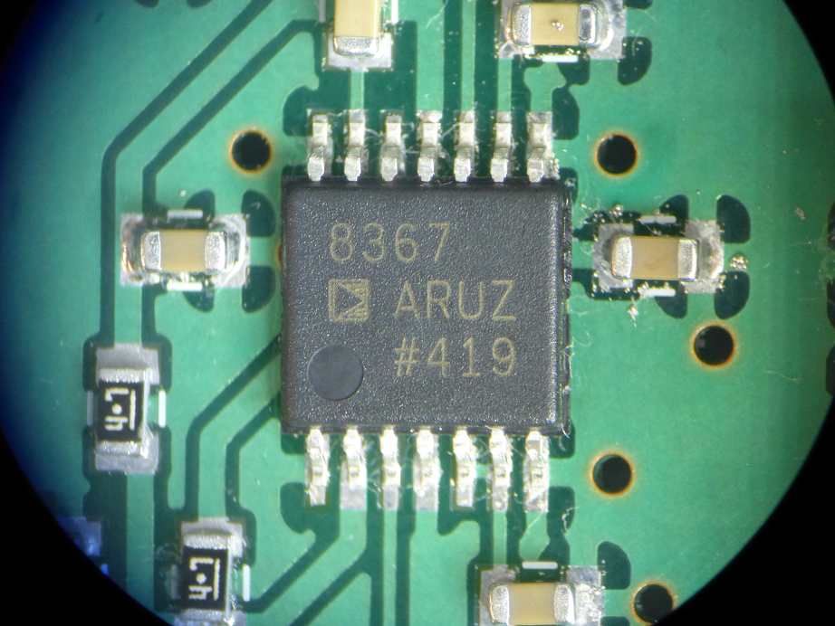

Figure 26: The end result of an IC component, resistors, and capacitors after a successful application of solder paste using a hot plate.

**5. Kicking and Screaming: Removing Solder to Remove Components from the Board**

Sometimes errors can happen when soldering, but most times they can be fixed. Removing set solder is one of the most common tasks in removing components or fixing something wrong on the board.

You can also clip the extra leads of the component to give a cleaner look and clean up the surface with splattered flux from the solder using isopropanol. The following image shows a lead with too much solder.

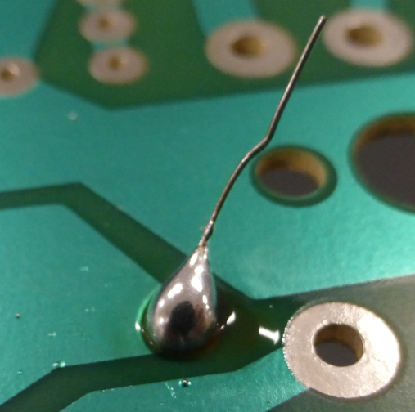

Figure 27: Too much solder on the pad that needs to be removed

A desoldering pump is one way of removing solder. It provides a small quick vacuum that sucks up the molten liquid solder.

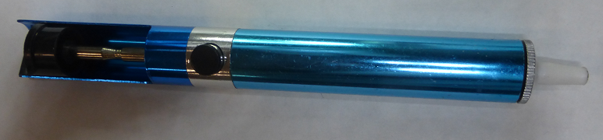

Figure 28: The desoldering pump, used to remove molten solder quickly

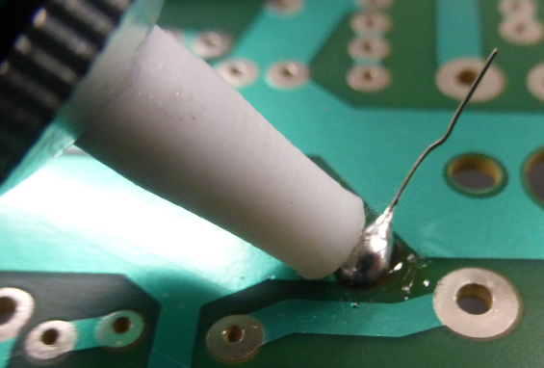

Figure 29: Place the desoldering pump close to the molten solder and hit the button to suck up the solder

An alternate method of removing solder and components is to use the solder wick. The solder wick absorbs melted solder.

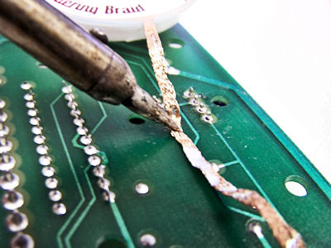

Figure 30: The solder wick at work. It is placed over the solder that needs to be removed and the soldering iron is used to melt the solder. The liquid solder will be absorbed by the solder wick.

**Non-Original Image References:**

Figure 3:

http://pixgood.com/solder-flux-paste.html

Figure 10:

http://ohararp.com/wp-content/uploads/2014/05/IAS_Step3.jpg

Figure 30:

http://www.jeffsgames.com/images/arcade/games/tron/tron2/chipremoval4.jpg